Fuses **487487487487487**

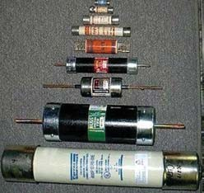

**CONTENTS**

20

C H A P TER

**Fuses**

# Introduction

* 1. **Fuses**
  2. **Desirable Characteristics of Fuse Element**
  3. **Fuse Element Materials**
  4. **Important Terms**
  5. **Types of Fuses**
  6. **Low Voltage Fuses**
  7. **High Voltage Fuses**
  8. **Carrent Carrying Capacity of Fuse Element**
  9. **Difference Between a Fuse and Circuit Breaker**

**I**

t was discussed in the previous chapter that a circuit breaker interrupts the circuit auto- matically on the occurrence of a short-cir-

cuit fault. The same function can also be per- formed by a fuse, though with lesser reliability and efficiency. Invented in 1890 by Edison, fuse is the cheapest form of protection against exces- sive currents. Many improvements have been made since the invention of first crude model. Now-a-days, several types of fuses are available which find extensive use in low to moderate volt- age applications where frequent operations are not expected or where the use of circuit breaker is uneconomical. In this chapter, we shall con- fine our attention to the various types of fuses and their applications in the fast expanding power system.

# Fuses

*A* **fuse** *is a short piece of metal, inserted in the circuit, which melts when excessive current flows through it and thus breaks the circuit.*

The fuse element is generally made of mate- rials having low melting point, high conductivity and least deterioration due to oxidation *e.g*., sil- ver, copper etc. It is inserted in series with the

**487**



**CONTENTS**

circuit to be protected. Under normal operating conditions, the fuse element is at a temperature below its melting point. Therefore, it carries the normal current without overheating. However, when a short-circuit or overload occurs, the current through the fuse increases beyond its rated value. This raises the temperature and fuse element melts (or blows out), disconnecting the circuit protected by it. In this way, a fuse protects the machines and equipment from damage due to excessive currents.

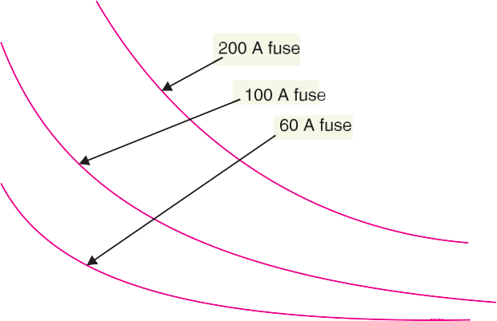

The time required to blow out the fuse depends upon the magnitude of excessive current. The greater the current, the smaller is the time taken by the fuse to blow out. In other words, a fuse has inverse time-current characteristics as shown in Fig. 20.1. Such a characteristic permits its use for overcurrent protection.

## Advantages

1. It is the cheapest form of protection available.
2. It requires no maintenance.
3. Its operation is inherently completely automatic unlike a circuit breaker which requires an elaborate equipment for automatic action.
4. It can break heavy short-circuit currents without noise or smoke.
5. The smaller sizes of fuse element impose a current limiting effect under short-circuit condi- tions.
6. The inverse time-current characteristic of a fuse makes it suitable for overcurrent protection.
7. The minimum time of operation can be made much shorter than with the circuit breakers.

## Disadvantages

1. Considerable time is lost in rewiring or replacing a fuse after operation.
2. On heavy short-circuits, *discrimination between fuses in series cannot be obtained unless there is sufficient difference in the sizes of the fuses concerned.
3. The current-time characteristic of a fuse cannot always be co-related with that of the pro- tected apparatus.

* Discrimination between two fuses is said to occur if on the occurrence of a short-circuit or overcurrent fault, only the desired fuse operates.

Fuses **489**



# Desirable Chara c teristics of Fuse Element

The function of a fuse is to carry the normal current without overheating but when the current exceeds its normal value, it rapidly heats up to melting point and disconnects the circuit protected by it. In order that it may perform this function satisfactorily, the fuse element should have the following desirable characteristics :

* + 1. low melting point *e.g.,* tin, lead.
    2. high conductivity *e.g*., silver, copper.
    3. free from deterioration due to oxidation *e.g*., silver.
    4. low cost *e.g*., lead, tin, copper.

The above discussion reveals that no material possesses all the characteristics. For instance, lead has low melting point but it has high specific resistance and is liable to oxidation. Similarly, copper has high conductivity and low cost but oxidises rapidly. Therefore, a compromise is made in the selection of material for a fuse.

# Fuse Element M aterials

The most commonly used materials for fuse element are lead, tin, copper, zinc and silver. For small currents upto 10 A, tin or an alloy of lead and tin (lead 37%, tin 63%) is used for making the fuse element. For larger currents, copper or silver is employed. It is a usual practice to tin the copper to protect it from oxidation. Zinc (in strip form only) is good if a fuse with considerable time-lag is required *i.e*., one which does not melt very quickly with a small overload.

The present trend is to use silver despite its high cost due to the following reasons :

* + 1. It is comparatively free from oxidation.
    2. It does not deteriorate when used in dry air.
    3. The coefficient of expansion of silver is so small that no critical fatigue occurs. Therefore, the fuse element can carry the rated current continuously for a long time.
    4. The conductivity of silver is very high. Therefore, for a given rating of fuse element, the mass of silver metal required is smaller than that of other materials. This minimises the problem of clearing the mass of vapourised material set free on fusion and thus permits fast operating speed.
    5. Due to comparatively low specific heat, silver fusible elements can be raised from normal temperature to vapourisation quicker than other fusible elements. Moreover, the resistance of silver increases abruptly as the melting temperature is reached, thus making the transition from melting to vapourisation almost instantaneous. Consequently, operation becomes very much faster at higher currents.
    6. Silver vapourises at a temperature much lower than the one at which its vapour will readily ionise. Therefore, when an arc is formed through the vapourised portion of the element, the arc path has high resistance. As a result, short-circuit current is quickly interrupted.

# Im p ortant Terms

The following terms are much used in the analysis of fuses :

* + 1. **Current rating of fuse element.** It is the current which the fuse element can normally carry without overheating or melting. It depends upon the temperature rise of the contacts of the fuse holder, fuse material and the surroundings of the fuse.
    2. **Fusing current.** It is the minimum current at which the fuse element melts and thus discon- nects the circuit protected by it. Obviously, its value will be more than the current rating of the fuse element.

For a round wire, the approximate relationship between fusing current *I* and diameter *d* of the wire is

**490** Prin ciples of Power System



*I* = *k d*3/2

where *k* is a constant, called the *fuse constant*. Its value depends upon the metal of which the fuse element is made. Sir W.H. Preece found the value of *k* for different materials as given in the table below :

|  |  |  |  |
| --- | --- | --- | --- |
| **S. No.** | **Material** | **Value of k** | |
| **d in cm** | **d in mm** |
| 1 | Copper | 2530 | 80 |
| 2 | Aluminium | 1873 | 59 |
| 3 | Tin | 405·5 | 12·8 |
| 4 | Lead | 340·6 | 10·8 |

The fusing current depends upon the various factors such as :

* + - 1. material of fuse element
      2. length – the smaller the length, the greater the current because a short fuse can easily conduct away all the heat
      3. diameter
      4. size and location of terminals
      5. previous history
      6. type of enclosure used
    1. **Fusing factor.** It is the ratio of minimum fusing current to the current rating of the fuse element *i.e.*

Fusing factor = Minimum fusing current

Current rating of fuse

Its value is always more than one. The smaller the fusing factor, the greater is the difficulty in avoiding deterioration due to overheating and oxidation at rated carrying current. For a semi-en- closed or rewirable fuse which employs copper wire as the fuse element, the fusing factor is usually 2. Lower values of fusing factor can be employed for enclosed type cartridge fuses using silver or bimetallic elements.

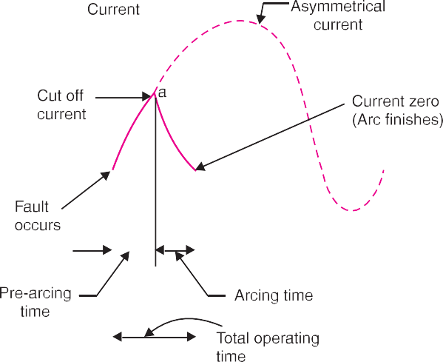

Fuses **491**



* + 1. **Prospective Current.** Fig. 20.2 shows how a.c. current is cut off by a fuse. The fault current would normally have a very large first loop, but it actually generates sufficient en- ergy to melt the fuseable element well before the peak of this first loop is reached. The *r.m.s.* value of the first loop of fault current is known as prospective current. Therefore, prospec- tive current can be defined as under:

*It is the r.m.s. value of the first loop of the fault current obtained if the fuse is replaced by an ordinary conductor of negligible resistance.*

* + 1. **Cut-off current.** It is the maximum value of fault current actually reached before the fuse melts.

On the occurrence of a fault, the fault current has a very large first loop due to a fair degree of asymmetry. The heat generated is sufficient to melt the fuse element well before the peak of first loop is reached (point ‘*a*’ in Fig. 20.2). The current corresponding to point ‘*a*’ is the cut off current. The cut off value depends upon :

1. current rating of fuse
2. value of prospective current
3. asymmetry of short-circuit current

It may be mentioned here that outstanding feature of fuse action is the breaking of circuit *before* the fault current reaches its first peak. This gives the fuse a great advantage over a circuit breaker since the most severe thermal and electro-magnetic effects of short-circuit currents (which occur at the peak value of prospective current) are not experienced with fuses. Therefore, the circuits pro- tected by fuses can be designed to withstand maximum current equal to the cut-off value. This consideration together with the relative cheapness of fuses allows much saving in cost.

* + 1. **Pre-arcing time.** It is the time between the commencement of fault and the instant when cut off occurs.

When a fault occurs, the fault current rises rapidly and generates heat in the fuse element. As the fault current reaches the cut off value, the fuse element melts and an arc in initiated. The time from the start of the fault to the instant the arc is initiated is known as pre-arcing time. The pre-arcing time is generally small : a typical value being 0·001second

* + 1. **Arcing time.** This is the time between the end of pre-arcing time and the instant when the arc is extinguished.
    2. **Total operating time.** It is the sum of pre-arcing and arcing times.

It may be noted that operating time of a fuse is generally quite low (say 0·002 sec.) as compared to a circuit breaker (say 0·2 sec or so). This is an added advantage of a fuse over a circuit breaker. A fuse in series with a circuit breaker of low-breaking capacity is a useful and economical arrangement to provide adequate short-circuit protection. It is because the fuse will blow under fault conditions before the circuit breaker has the time to operate.

* + 1. **Breaking capacity.** It is the r.m.s. value of a.c. component of maximum prospective current that a fuse can deal with at rated service voltage.

# Typ es of Fuses

Fuse is the simplest current interrupting device for protection against excessive currents. Since the invention of first fuse by Edison, several improvements have been made and now-a-days, a variety of fuses are available. Some fuses also incorporate means for extinguishing the arc that appears when the fuse element melts. In general, fuses may be classified into :

* + 1. Low voltages fuses **(*ii*)** High voltage fuses

It is a usual practice to provide isolating switches in series with fuses where it is necessary to permit fuses to be replaced or rewired with safety. If such means of isolation are not available, the

**492** Prin ciples of Power System



fuses must be so shielded as to protect the user against accidental contact with the live metal when the fuse carrier is being inserted or removed.

# Low Voltag e Fuses

Low voltage fuses can be subdivided into two classes *viz*., (*i*) semi-enclosed rewireable fuse (*ii*) high rupturing capacity (H.R.C.) cartridge fuse.

1. **Semi-enclosed rewireable fuse.** Rewireable fuse (also known as kit-kat type) is used where low values of fault current are to be interrupted. It consists of (*i*) a base and (*ii*) a fuse carrier. The base is of porcelain and carries the fixed contacts to which the incoming and outgoing phase wires are connected. The fuse carrier is also of porcelain and holds the fuse element (tinned copper wire) between its terminals. The fuse carrier can be inserted in or taken out of the base when desired.

When a fault occurs, the fuse element is blown out and the circuit is interrupted. The fuse carrier is taken out and the blown out fuse element is replaced by the new one. The fuse carrier is then re- inserted in the base to restore the supply. This type of fuse has two advantages. Firstly, the detach- able fuse carrier permits the replacement of fuse element without any danger of coming in contact with live parts. Secondly, the cost of replacement is negligible.

## Disadvantages

1. There is a possibility of renewal by the fuse wire of wrong size or by improper material.
2. This type of fuse has a low-breaking capacity and hence cannot be used in circuits of high fault level.
3. The fuse element is subjected to deterioration due to oxidation through the continuous heat- ing up of the element. Therefore, after some time, the current rating of the fuse is decreased *i.e*., the fuse operates at a lower current than originally rated.
4. The protective capacity of such a fuse is uncertain as it is affected by the ambient conditions.
5. Accurate calibration of the fuse wire is not possible because fusing current very much de- pends upon the length of the fuse element.

Semi-enclosed rewireable fuses are made upto 500 A rated current, but their breaking capacity is low *e.g*., on 400 V service, the breaking capacity is about 4000 A. Therefore, the use of this type of fuses is limited to domestic and lighting loads.

1. **High-Rupturing capacity (H.R.C.) cartridge fuse.** The primary objection of low and uncertain breaking capacity of semi-enclosed rewireable fuses is overcome in H.R.C. cartridge fuse. Fig. 20.3 shows the essential parts of a typical H.R.C. cartridge fuse. It consists of a heat resisting ceramic body having metal end-caps to which is welded silver current-carrying element. The space within the body surrounding the element is completely packed with a filling powder. The filling material may be chalk, plaster of paris, quartz or marble dust and acts as an arc quenching and cooling medium.

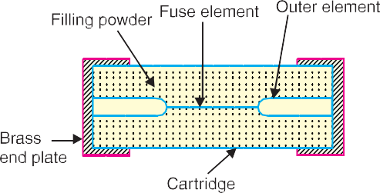

Under normal load conditions, the fuse element is at a temperature below its melting point.

Fuses **493**



Therefore, it carries the normal current without overheating. When a fault occurs, the current in- creases and the fuse element melts before the fault current reaches its first peak. The heat produced in the process vapourises the melted silver element. The chemical reaction between the silver vapour and the filling powder results in the formation of a high resistance substance which helps in quench- ing the arc.

## Advantages

1. They are capable of clearing high as well as low fault currents.
2. They do not deteriorate with age.
3. They have high speed of operation.
4. They provide reliable discrimination.
5. They require no maintenance.
6. They are cheaper than other circuit interrupting devices of equal breaking capacity.
7. They permit consistent performance.

## Disadvantages

1. They have to be replaced after each operation.
2. 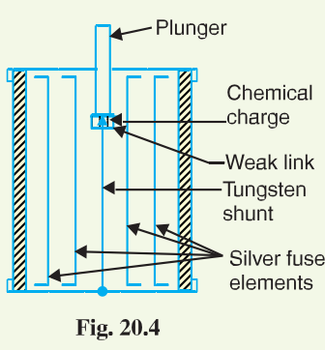Heat produced by the arc may affect the associated switches.
3. **H.R.C. fuse with tripping device.** Sometime, H.R.C. cartridge fuse is provided with a tripping device. When the fuse blows out under fault conditions, the tripping device causes the circuit breaker to operate. Fig. 20.4 shows the essential parts of a

H.R.C. fuse with a tripping device. The body of the fuse is of ceramic material with a metallic cap rigidly fixed at each end. These are connected by a number of silver fuse elements. At one end is a plunger which under fault conditions hits the tripping mechanism of the circuit breaker and causes it to operate. The plunger is electrically connected through a fusible link, chemical charge and a tungsten wire to the other end of the cap as shown.

When a fault occurs, the silver fuse elements are the first to

be blown out and then current is transferred to the tungsten wire. The weak link in series with the tungsten wire gets fused and causes the chemical charge to be detonated. This forces the plunger outward to operate the circuit breaker. The travel of the plunger is so set that it is not ejected from the fuse body under fault conditions.

**Advantages.** H.R.C. fuse with a tripping device has the following advantages over a H.R.C. fuse without tripping device :

* + 1. In case of a single phase fault on a three-phase system, the plunger operates the tripping mechanism of circuit breaker to open all the three phases and thus prevents “single phas- ing”.
    2. The effects of full short circuit current need not be considered in the choice of circuit breaker. This permits the use of a relatively inexpensive circuit breaker.
    3. The fuse-tripped circuit breaker is generally capable of dealing with fairly small fault cur- rents itself. This avoids the necessity for replacing the fuse except after highest currents for which it is intended.

Low voltage H.R.C. fuses may be built with a breaking capacity of 16,000 A to 30,000 A at 440V. They are extensively used on low-voltage distribution system against over-load and short- circuit conditions.

**494** Prin ciples of Power System



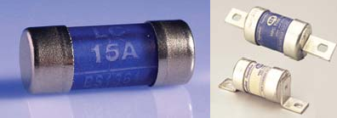

# High Voltage Fuses

HRC Fuse

The low-voltage fuses discussed so far have low normal current rating and breaking capacity. Therefore, they cannot be successfully used on modern high voltage circuits. Intensive research by the manufacturers and supply engineers has led to the development of high voltage fuses. Some of the high voltage fuses are :

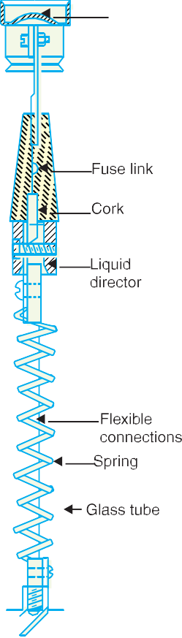

* + 1. **Cartridge type.** This is similar in general construction to the low voltage cartridge type except that special design features are incorpo- rated. Some designs employ fuse elements wound in the form of a helix so as to avoid corona effects at higher voltages. On some designs, there are two fuse elements in parallel ; one of low resistance (silver wire) and the other of high resistance (tungsten wire). Under normal load condi- tions, the low resistance element carries the normal current. When a fault occurs, the low-resistance element is blown out and the high resistance element reduces the short-circuit current and finally breaks the circuit.

High voltage cartridge fuses are used upto 33 kV with breaking ca- pacity of about 8700 A at that voltage. Rating of the order of 200 A at 6·6 kV and 11 kV and 50 A at 33 kV are also available.

* + 1. **Liquid type.** These fuses are filled with carbon tetrachloride and have the widest range of application to h.v. systems. They may be used for circuits upto about 100 A rated current on systems upto 132 kV and may have breaking capacities of the order of 6100 A.

Fig. 20.5 shows the essential parts of the liquid fuse. It consists of a glass tube filled with carbon tetrachloride solution and sealed at both ends with brass caps. The fuse wire is sealed at one end of the tube and the other end of the wire is held by a strong phosphor bronze spiral spring fixed at the other end of the glass tube. When the current exceeds the prescribed limit, the fuse wire is blown out. As the fuse melts, the spring retracts part of it through a baffle (or liquid director) and draws it well into the liquid. The small quantity of gas generated at the point of fusion forces some part of liquid into the passage through baffle and there it effectively extinguishes the arc.

* + 1. **Metal clad fuses.** Metal clad oil-immersed fuses have been developed with the object of providing a substitute for the oil circuit breaker. Such fuses can be used for very high voltage circuits and operate most satisfactorily under short-circuit conditions approaching their rated capacity.

Fuses **495**



# Current Carr ying Ca pa city of Fuse Element

The current carrying capacity of a fuse element mainly depends on the metal used and the cross- sectional area but is affected also by the length, the state of surface and the surroundings of the fuse. When the fuse element attains steady temperature,

Heat produced per sec = Heat lost per second by convection, radiation

and conduction

or *I*2*R* = Constant  Effective surface area or *I*2 FH  *l* IK = constant  *d*  *l*

*a*

where *d* = diameter of fuse element

*l* = length of fuse element

   *l*

 *I*2

a / 4f *d*2

= constant  *d*  *l*

or *I*2 = constant  *d*3

or *I*2  *d*3 ...(*i*)

Expression (*i*) is known as ordinary *fuse law*.

**Example 20.1.** *A fuse wire of circular cross-section has a radius of 0·8 mm. The wire blows off at a current of 8A. Calculate the radius of the wire that will blow off at a current of 1A.*

## Solution.

*I*2  *r*3

F *I* I2 F*r* I3

 G 2 J =

G 2 J

H *I*1 K H *r*1 K

or *r*2 = *r*1  FG *I*2 IJ2 /3  0  8  FH1IK2/ 3 = **0·2 mm**

H *I*1 K 8

# Difference Between a Fuse and Cir cuit Bre aker

It is worthwhile to indicate the salient differences between a fuse and a circuit breaker in the tabular form.

|  |  |  |  |
| --- | --- | --- | --- |
| **S. No.** | **Particular** | **Fuse** | **Circuit breaker** |
| 1. | *Function* | It performs both detection and | It performs interruption function |
|  |  | interruption functions. | only. The detection of fault is |
|  |  |  | made by relay system. |
| 2. | *Operation* | Inherently completely automatic. | Requires elaborate equipment |
|  |  |  | (*i.e*. relays) for automatic action. |
| 3. | *Breaking capacity* | Small | Very large |
| 4. | *Operating time* | Very small (0·002 sec or so) | Comparatively large (0·1 to 0·2 |
|  |  |  | sec) |
| 5. | *Replacement* | Requires replacement after every | No replacement after operation. |
|  |  | operation. |  |

# SELF - TEST

1. **Fill in the blanks by inserting appropriate words/figures**
   1. Fuses are generally used in circuits where operations are not expected.
   2. The minimum time of operation of a fuse is than that of a circuit breaker.

**496** Prin ciples of Power System



* 1. A fuse element should have melting point.
  2. The disadvantages of tin fuse element is that its vapour tends to when it blows out.
  3. The value of fusing factor is always than unity
  4. Semi-enclosed rewireable fuses have breaking capacity.
  5. A fuse has time current characteristics.
  6. The action of a fuse is completely automatic.
  7. The fuse element is generally made of ...............
  8. The fuse melts well the first peak of fault current is reached.

1. **Pick up the correct words/figures from the brackets and fill in the blanks.**
   1. A fuse is than other circuit interrupting device of equal breaking capacity.

(*cheaper, costlier*)

* 1. For the same material, heavy-current fuse wires must have diameters than for smaller

currents. (*larger, smaller*)

* 1. A fuse performs ............... functions. (*both detection and interruption, interruption*)
  2. A fuse has ............... breaking capacity as compared to a circuit breaker. (*low, high*)

ANSWERS TO SELF-TEST

1. (*i*) frequent (*ii*) smaller (*iii*) low (*iv*) maintain the arc (*v*) more (*vi*) low (*vii*) inverse (*viii*) inherently

(*ix*) silver (*x*) before

1. (*i*) cheaper (*ii*) larger (*iii*) both detection and interruption (*iv*) low

# CHAPTER REVIEW TOPICS

1. What is a fuse ? Discuss the advantages and disadvantages of a fuse.
2. Why do we prefer silver as a fuse element ?
3. Define and explain the following terms :
   1. fusing current (*ii*) cut off current (*iii*) operating time (*iv*) breaking capacity
4. Write short notes on the following :
   1. Semi-enclosed rewireable fuse
   2. H.R.C. cartridge fuse
   3. Difference between a fuse and circuit breaker

DISCUSSION QUESTIONS

1. Why are circuit breakers preferred to fuses ?
2. Why fuses cannot provide adequate discrimination on heavy short-circuit ?
3. Why fuses can interrupt heavy short-circuit currents successfully ?



GO To FIRST